

Department Of Computer science

**DIGITAL LOGIC DESIGN LAB**

**ELECTRONIC DICE**

**Prepared by:**

|  |  |
| --- | --- |
| **ZAINAB RAUF** | **02-134221-057** |
|  |  |

**BS (CS) -2A**

**FALL 2022**

**Submitted to**

**MIRZA WAQAS BAIG**

Table of Contents

1. Abstract 3

2. Introduction 3

3. Literature Review 3

4. Components .. 3

5. Methodology 4

**5.1. ProposedModel………………......................................................…...4**

**5.2 Circuit Description……………………………………………….…..5**

6. Results and Discussions 5

7. Conclusion and Future Work 5

8. Project Summary 6

9. Project Pictures 6

10. References 6

1. **ABSTRACT :**

* Electronic dice that can be made to generate a random number. It can be used like a normal dice in games. The dice works by switching Light Emitting Diodes (LEDs) on and off in the pattern of dots found on a traditional dice. The microcontroller is the ‘brain’ of the dice. Microcontrollers are powerful electronic components that have a memory and can be programmed to switch things on and off in any sequence. The microcontroller in the dice can switch the LEDs on and off to show numbers between one and six.

1. **INTRODUCTION :**

Electronic dice helps to generate random numbers and it various used for play games and it compatible and entertainment purpose for children.

Dice is used to play many games like snake ladder, Ludo etc. Generally dice is made up of wooden or plastic, which gets deformed with time and become biased. A **Digital dice** is a good alternative of old fashioned dice, it can’t be biased or deformed. It operates at such high speed that no one can cheat. To create this digital dice circuit, we have mainly used 555 timer IC and 4017 IC.

1. **LITERATURE REVIEW :**

You must have played with a dice at some time, for example when playing Ludo or Monopoly. Dice have existed for a very long time. The first known six-sided dice were found in Iraq and were made in 2750 B.C. They were made of terracotta, with small holes for the spots. Originally dice were used for sorcery and to predict the future. A wise man from the village would roll the dice and, depending on the outcome, would predict what auspicious or inauspicious events were going to happen in the future. As time went on, however, dice were used more and more for gambling and playing games.

1. **COMPONENTS :**

. CD4017 IC

. 555 Timer IC

. 2 Resistor- 1k

. Capacitor- 10uF

. Variable Resistor- 10K

. Push Button

. 6 LEDs

. Battery - 9v

**4**. **CIRCUIT DIAGRAM:**

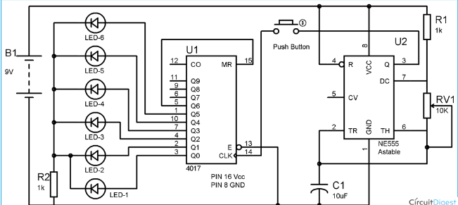

1. **METHODOLOGY:**
   1. **Proposed Model :**

* A **Digital dice** is a good alternative of old fashioned dice, it can’t be biased or deformed. It operates at such high speed that no one can cheat. To create this digital dice circuit, we have mainly used [555 timer IC](http://circuitdigest.com/555-timer-circuits) and 4017 IC.
* The models include contact detection, compression, load bearing, and deflection. The results could serve as a basic building block for innovative touch sensor designs for mobile robot sensor fusion systems.
  1. **Circuit Description :**
* We connect positive terminal of the leds to the IC 4017 at pin 1,2,3,4,7,10 and negative terminal of leds connect with ground. Then short pin 5 with pin 15. After that pin 13 and negative terminal of leds whose connects with pin 10 connect also with ground. And connect pin 16 with the positive terminal of the battery. And in last we leave naked wire from pin 14 for operating electronic dice.
* We connect positive terminal of the buzzer battery and negative terminal with collector of transistor and base with emitter of transistor and emitter of transistor with negative terminal of battery. The 10k resistor one end connect with positive terminal of battery and other with collector of transistor and in last two naked wire leave one from collector of transistor and other with base of transistor.

1. **RESULTS AND DISCUSSIONS :**

* If we want to play with electronic dice then first connect battery with the circuit and after giving ground with circuit we are able to play with electronic dice. we touch only one time on naked wire for generating random led on these leds show me any number you chosen and when we again touch on naked wire the random led will glow and it works like a dice.

1. **CONCLUSION AND FUTURE WORK :**

A digital dice is the best alternative for entertainment purposes like in board

Games. The low cost and vast availability makes this device more interesting.

This device can be a good use in our everyday lives.

The goal of electronic dice project is to use for entertaining children for play various games and also touch sensor project used for security purpose. In future it is more helpful and useful for other purposes like security for cars and expensive things.

1. **PROJECT SUMMARY :**

This digital dice project is an interesting project that will display in random the number from 1 to 9 on the 7 segment display. This is an alternative device that can be used to replace the traditional dice when you are playing games such as snake ladder and monopoly. The generation of clock is done by using a 555 timer which is connected in the stable mode at a frequency of approximately 50 Hz. The 555 timer is the most commonly used integrated circuit in many projects and it is a good idea to get used to this device as soon as you can. On top of that, the cost of this IC is reasonably cheap compared to other ICs.

1. **PROJECT PICTURES** 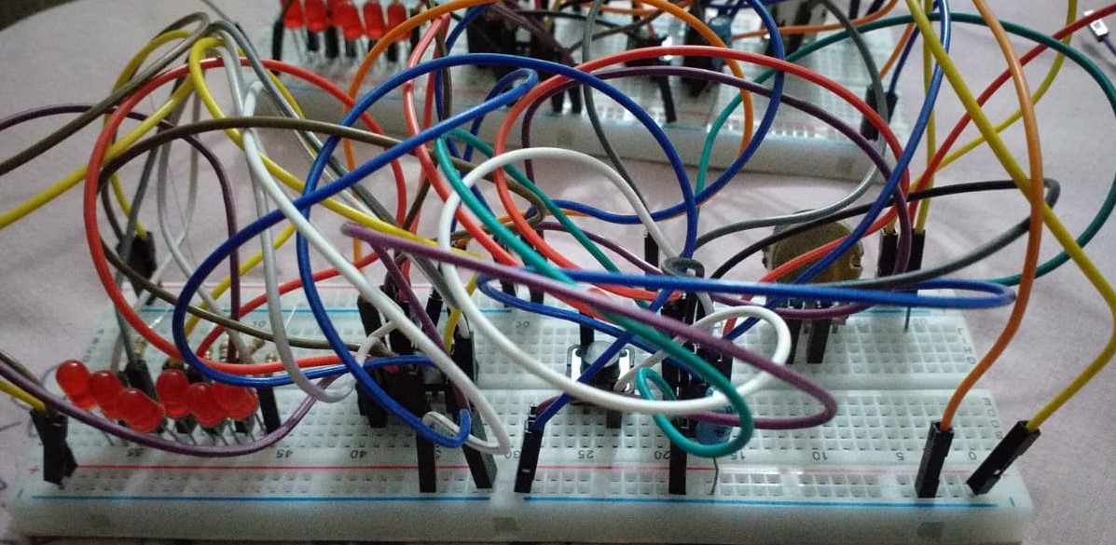

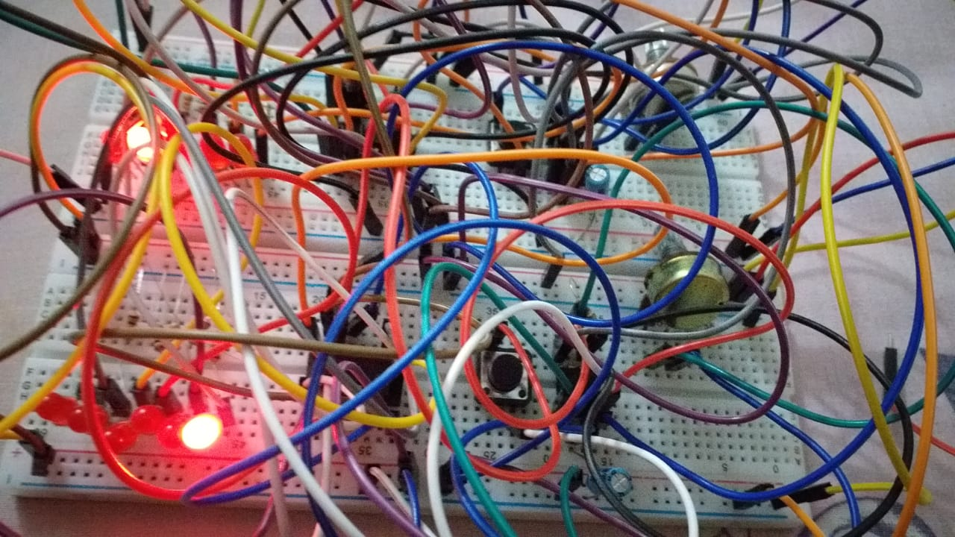

1. **REFERENCES :**

<https://circuitdigest.com/electronic-circuits/digital-dice-circuit-using-ic-555>

https://startingelectronics.org/beginners/start-electronics-now/tut17-electronic-dice/